厦门双十中学2018届中考总复习第二轮模拟考试卷
英 语
（试卷满分：150分 考试时间：120分钟）
学校____________ 姓名____________ 座位号____________

I. 听音理解 （共三节，20小题，每小题1.5分，满分30分）
第一节 听句子 听下面五个句子，从每小题所给的三幅图中选出与句子内容相符的选项。
（每个句子读两遍）
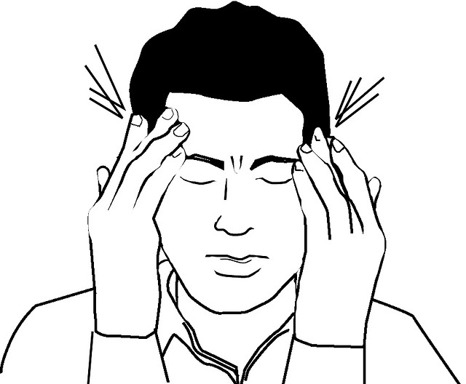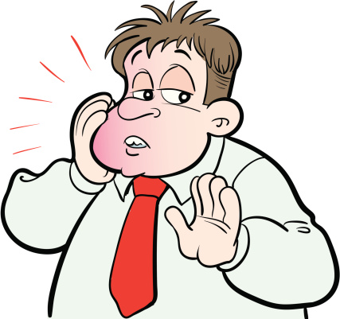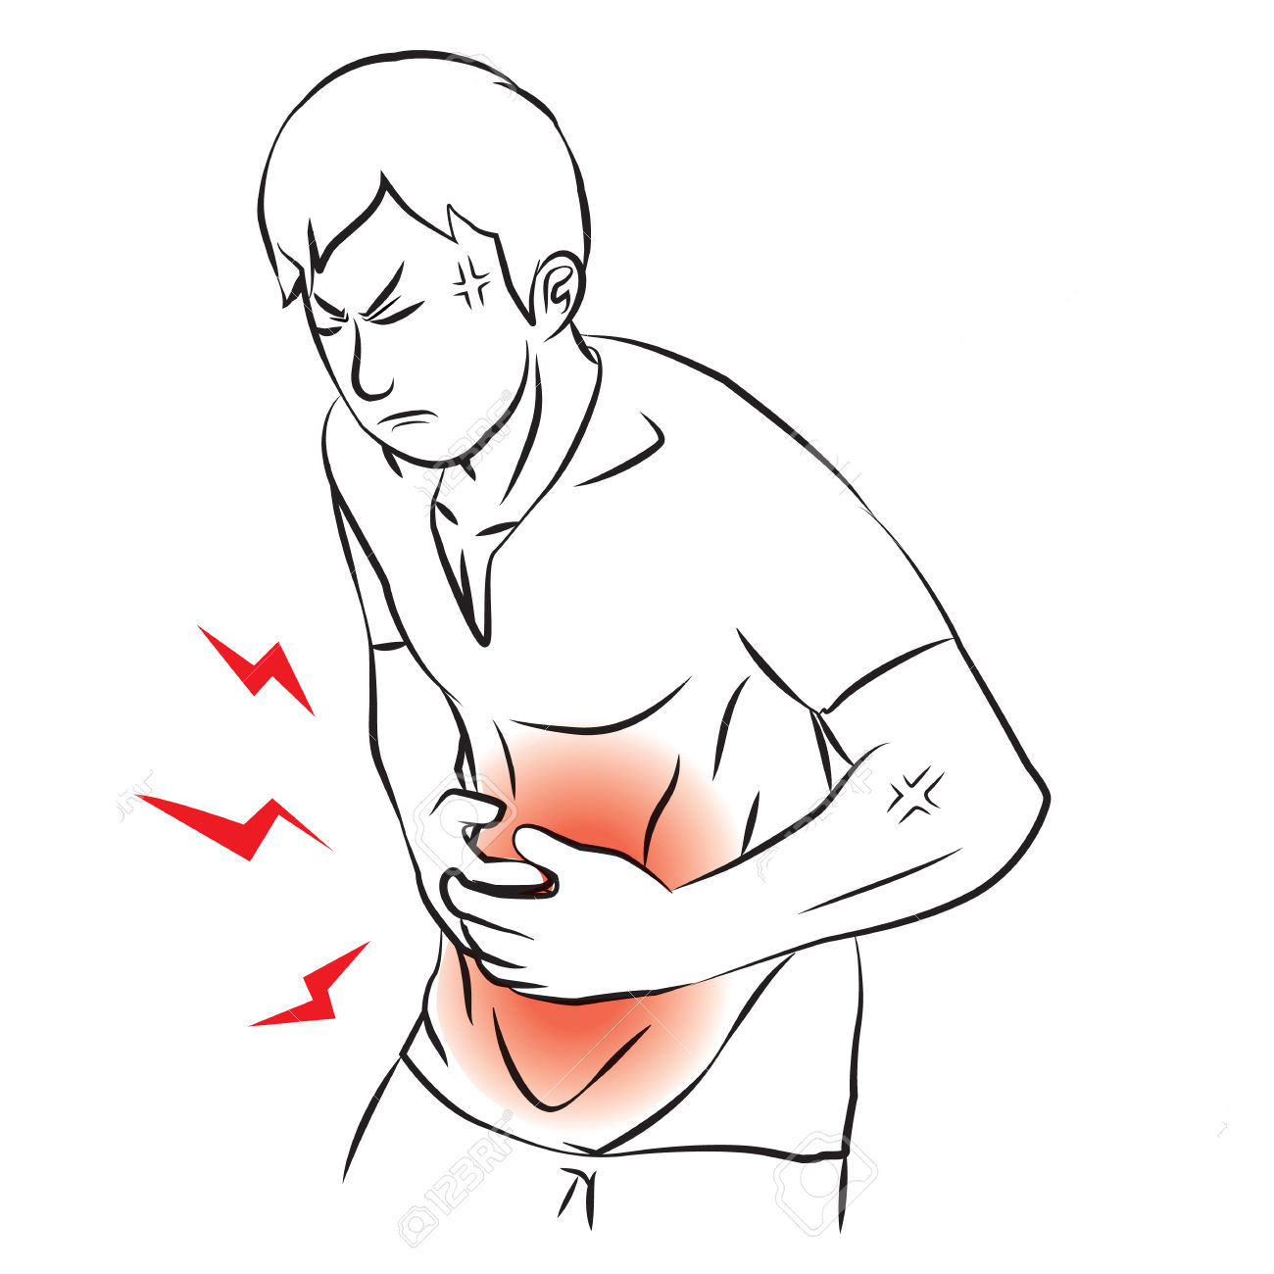
1. A B C
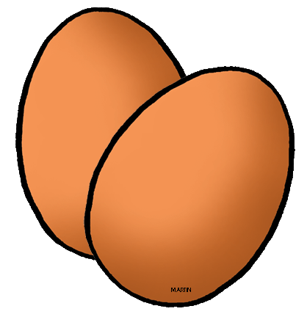
2. A B C
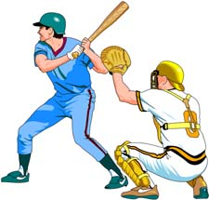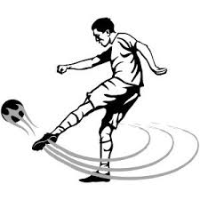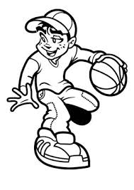
3. A B C
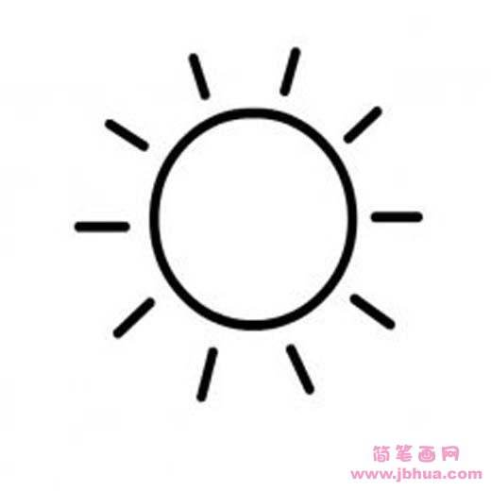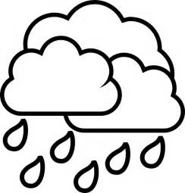
4. A B C
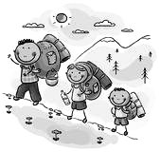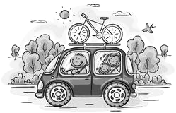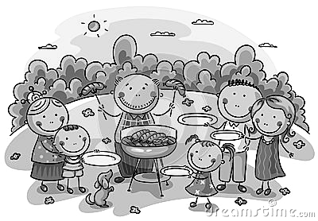
5. A B C

第二节 听对话 听下面七段对话，从每小题所给的A、B、C三个选项中选出正确答案。
（每段对话读两遍）
听第1段对话，回答第6小题。
6. What does the man want to buy?
A. A white shirt. B. A yellow hat. C. A green sweater.
听第2段对话，回答第7小题。
7. What does Amy want to be when she grows up?
A. A teacher. B. A reporter. C. A doctor.
听第3段对话，回答第8小题。
8. Where are the two speakers?
A. In a library. B. In a supermarket. C. In a cinema.
听第4段对话，回答第9小题。
9. How does the woman feel?
A. Bored. B. Moved. C. Angry.
听第5段对话，回答第10、11小题。
10. When are they going to Shanghai Disneyland?
A. This Friday. B. This Saturday. C. This Sunday.
11. How are they going to Shanghai?
A. By train. B. By car. C. By plane.
听第6段对话，回答第12、13小题。
12. What’s Mary’s favorite animal?
A. Elephants. B. Giraffes. C. Lions.
13. What does John think of elephants now?
A. Scary. B. Friendly. C. Tall.
听第7段对话，回答第14、15小题。
14. What does the man want to have?
A. A hamburger. B. A baked potato. C. A banana shake.
15. How much does the meal cost?
A. $1. B. $2. C. $3.
………………………………………………………………………………………………………………………………
注意：请将该题的答案书写在答题卡的第二部分
第三节 听对话 根据所听到的对话内容完成表格，每空一词。（对话读三遍)

Name | Brenda
Work time | From 9 a.m. to 16 p.m.
Problem | Put on 17
Advice | Eat less meat and more 18
Advice | 19 more
Advice | Go to the keep-fit 20
II. 单项选择 从每小题所给的A、B、C三个选项中，选出可以填入空白处的正确答案。
（每小题1分，满分15分）
21. -- How do you know Jack’s father is a pilot?
-- I once read __________ article about him.
A. a B. an C. the
22. --Sometimes, I really can’t understand why my parents are so strict with me.
--__________ imagining yourself in their positions, I think you can understand them better.
A. By B. In C. Of
23. Whenever we had a meeting, he was never late, which impressed us much with his sense of __________.
A. humor B. time C. art
24. --Stop playing with your phone. It’s time to have a meeting.
--Thank you for __________ me.
A. inviting B. reminding C. encouraging
25. She had planned to go traveling this summer, but some extra work __________ all her time.
A. put up B. made up C. took up
26. --Mr. Tang, could you please give me some advice on learning English?
--First of all, I think your spoken English will never improve if you remain __________ in class all the time.
A. silent B. active C. patient
27. --Did you have a nice sleep last night?
--Yes, never slept __________.
A. better B. best C. worse
28. --Today is Linda’s birthday. Have you bought her a gift?
--Oh, my god! I __________ forgot her birthday.
A. probably B. completely C. hardly
29. --Who should be responsible for this terrible traffic accident?
--It's not the right time to discuss that. __________, we should send her to hospital.
A. As a result B. All in all C. Above all
30. -- Can’t I park my car free here?
-- You can, for four hours, __________ you spend over 100 yuan in this supermarket.
A. though B. if C. unless
31. --Can I go now, sir?
--If you __________ leave, do it quietly.
A. should B. must C. may
32. --Excuse me, when can we play basketball on the playground?
--Not until the playground __________ next week.
A. will repair B. will be repaired C. is repaired
33. --The man I saw yesterday __________ around my house again.
--Let’s call the police right now.
A. was walking B. has walked C. is walking
34. The earth is the only planet __________ provides us with everything we need. It’s our duty to protect it.
A. who B. what C. that
35. -- He is too short to be a successful basketball player.
--__________. Every dog has its day.
A.I think so B. It's hard to say C. Lucky him
III. 完形填空 从每小题所给的A、B、C三个选项中，选出可以填入空白处的最佳答案。
（每小题1.5分，满分15分）
In June, 2013, I started my work at the animal shelter's Adoption (领养) Department. Over the years, more than 50000 animals have 36 the doors of the shelter (收容所). Sometimes there are 37 animals, who touch me so deeply that I could never forget them. Tabby was one such animal.
Tabby was an ancient Cooker Spaniel, probably 14 years old. What's more, she was blind and deaf. Tabby's chances of adoption seemed small. We all thought that Tabby would live out the rest of her life at the 38 .
One day a woman named Loretta came to the shelter. Her son, Gary, was interested in Tabby! What could a young child possibly see in a 14-year-old dog who was both blind and deaf? Most boys would want a dog who could grow with them and 39 through grassy fields on summer days. Tabby would 40 be able to do that. But after meeting her, Loretta and Gary decided that she was the right dog for their family. They adopted Tabby!
If Tabby′s story simply ended with her 41 adoption, it would still have been something very special indeed. 42 , it was what happened after her adoption that people might think to be "magic". Gary had seizures (癫痫).Since Gary and Tabby met, they have been friends. They became so "in tune" with one another that Tabby began to tell Gray's seizures 43 they appeared, giving his family a(n) 44 that one was about to strike (到达). What's more, Gary seemed to be having fewer and fewer seizures since Tabby arrived.
How could it be? Nobody could explain 45 Tabby did it. But those of us who were lucky enough to know her family and witnessed the magic, know that it has its roots in love.
( )36. A. broken B. passed C. locked
( )37. A. strange B. active C. special
( )38. A. hospital B. shelter C. farm
( )39. A. run B. get C. break
( )40. A. often B. exactly C. never
( )41. A. successful B. normal C. sad
( )42. A. However B. Moreover C. Perhaps
( )43. A. unless B. before C. since
( )44. A. explanation B. suggestion C. warning
( )45. A. when B. why C. how
IV. 阅读理解 （共两节，满分45分）
第一节 阅读以下A、B、C、D四篇短文，根据短文内容，从题中所给A、B、C、D四个选项中，选出最佳答案。（每小题2分，满分40分）
A
The Importance of First Aid
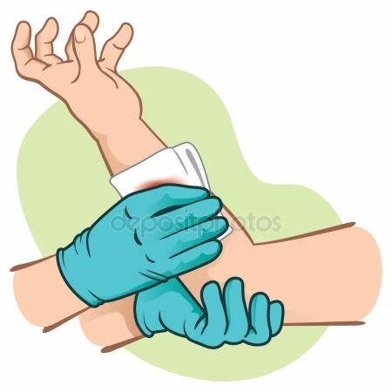
First aid is the immediate care given to a person who has been injured(受伤) or suddenly ill, including self-help and home care if medical help is not available or delayed. First aid knowledge means life or death during an emergency(紧急的) situation so that greatest possible good may be done for the greatest number of people.
General Treatment to Burns
● Move the injured away from the heat.
● Check the breathing as well as the size and depth of burns.
● Wash the burnt area with water to reduce pain.
● Cover the wound with a sterilized (消毒的) dressing.
● For burns on the face, use sheet or something else to cover the burnt area.
Heatstroke(中暑)
To avoid heatstroke, you should stop tiring activities in hot weather. If you still go outdoors, you should:
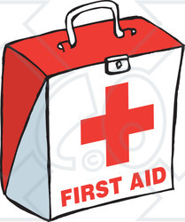
● wear light loose-fitting(宽松的) clothing;
● rest in a cool place as often as possible;
● drink boiled water or fruit juice;
● avoid drinks such as milk, wine and beer.
First Aid training
Some people go through specific training in order to provide first aid in public or at home, or other places where people get together. People performing a first aid role are often expected to have a high level of first aid training and are often uniformed. There are some organizations giving first aid courses recognized by the local government, such as the Red Cross. For more information, you can call the Fire Services Ambulance Command Training School on 2640 3708.
46. First aid is given ___________.
A. when doctors arrive B. before doctors arrive
C. after doctors arrive D. to patients in hospital
47. If someone’s arm is burnt by a fire, you should ___________.
A. cover his arms with some sheet B. cut his arm off to get it away from the fire
C. check the size of his arm first D. put his arm under some running water
48. It can be inferred that ___________ may cause heatstroke on a hot day.
A. light loose-fitting clothing B. boiled water or fruit juice
C. tiring outdoor activities D. staying in a cool place
49. First aiders ___________.
A. often wear uniforms B. don’t have much training
C. only provide first aid at home D. often get together in public
50. What is the writer’s main purpose of writing the passage?
A. To introduce some first aid training courses and schools.
B. To show the importance of first aid with some examples.
C. To praise an organization that is related to first aid training.
D. To tell the readers how to perform some first aid treatment.
B
Once upon a time, there was an island where all the feelings lived: Happiness, Sadness, Knowledge, and all of the others, including Love. One day the feelings were told that the island would sink, so all built boats and left, except Love. Love was the only one who stayed. Love wanted to hold on until the last possible moment.
When the island had almost sunk, Love decided to ask for help.
Richness was passing by Love in a big boat. Love said, “Richness, can you take me with you?”
Richness answered, “No, I can’t. There is a lot of gold and silver in my boat. There is no place here for you.”
Love decided to ask Vanity(虚荣心) who was also passing by in a beautiful ship. “Vanity, please help me!”
“I can’t help you, Love. You are all wet and might damage(破坏) my boat,” Vanity answered.
Sadness was close by so Love asked, “Sadness, let me go with you.”
“Oh…Love, I am so sad that I need to be by myself!”
Happiness passed by Love, too, but she was so happy that she did not even hear when Love called her.
Suddenly, there was a voice, “Come, Love, I will take you.” It was an elder. So thankful and happy, Love even forgot to ask the elder where they were going. When they arrived at dry land, the elder went her own way. Realizing how much was owed(欠) the elder, Love asked Knowledge, another elder, “Who helped me?”
“It was Time,” Knowledge answered.
“Time?” asked Love. “But why did Time help me?”
Knowledge smiled with deep wisdom and answered, “Because only Time is able to understand how valuable Love is.”
51. How did the feelings go away from the island?
A. By flying. B. By swimming. C. On foot. D. By water
52. How many feelings did Love ask for help but failed?
A.5. B.4 C.3 D.2
53. Which of the following is true?
A. Happiness was blind. B. Richness had a small boat.
C. Sadness wanted to stay alone. D. Vanity’s ship was damaged
54. Who saved Love?
A. Happiness. B. Knowledge. C. Richness. D. Time.
55. Which of the following might be the best title of the passage?
A. Different Feelings B. An Accident C.A sinking island D. Love and Time
C
Many people thought that U.S. President Calvin Coolidge always lived in the White House. However, he sometimes lived in the nearby Willard Hotel.
Once, in the middle of a night, the President woke up to see a thief searching his clothes. Coolidge calmly spoke up from the darkness, “I wish you wouldn’t take that watch.”
“Why?” asked the shocked man.
Coolidge answered, “Take it near the window and read what is engraved (雕刻) on the back of it.”
The man read, “Presented to Calvin Coolidge, Speaker of the House, by the Massachusetts General Court.” He was very surprised!
“Are you President Coolidge?” he asked. He had never thought he would find the president sleeping in a hotel!
“Yes, I am.” Coolidge said. Then he asked, “Why are you doing this, Son?”
The young man explained that he and two friends traveled to Washington during their college vacation. They spent all of their money and had no money to pay the hotel bill and the train tickets back to school.
Coolidge added up the cost. It came to $32. That may not sound like much now, but it was a big number then. “I’ll give you the $32 as a loan(借款),” the President said, “And I expect you to pay me back.”
The young man thanked him. Coolidge left him with this warning: “Son, you are a nice boy, you are better than you are acting. You are starting down the wrong road. Just remember who you are.”
It wasn’t until after the death of Mr. Coolidge that this story was allowed to come out. It was first published in the newspaper Los Angeles Times. And the most interesting of all is that the President’s notes show that the young man was indeed better than he was acting. He repaid the $32 loan in full.
56. How did the young man get to know the president?
A. By looking at the back of the watch. B. By looking at the loan.
C. The boss of the hotel told the young man about it. D. The president’s wife told the young man about it.
57. How did the young man travel to Washington with his friend?
A. By air. B. By bus. C. By train. D. On foot.
58. What can we infer from the passage?
A. The young man’s family was always poor
B. The hotel cost was rather expensive at that time
C. The young man never kept in touch with the president again
D. The young man learned a lesson from his experience with the president
59. How did people first get to know the story of the president with the young man?
A. From the president himself. B. From a newspaper.
C. From the young man’s notes. D. From the young man himself.
60. What is the main idea of the passage?
A. Money can be given up when necessary.
B. People should be forgiven（原谅）for their mistakes.
C. Everyone can become better after an unusual experience.
D. An act of kindness may change a person’s life.
D
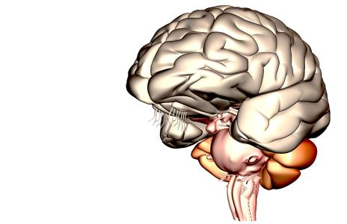
Your brain controls everything you do. It makes it possible for you to think, learn, create and feel; to blink(眨眼) and breathe and for your heart to heat –this fantastic control center is your brain. It is so amazing that a famous scientist once called it “the most complex(复杂) thing we have yet discovered in our universe”.
Can this small grey organ(器官), which weighs less than one and a half kilos, really do so much? Amazingly, your brain contains about 100 billion neurons(神经元) -it would take you over 3 ,000 years to count them all. Believe it or not, the activity in your brain never stops. Your neurons create and send more messages than all the phones in the world. And although one neuron creates only a little electricity, all your neurons together can produce enough electricity to power a light bulb (灯泡).
So exactly how fast does your brain work? Well, imagine this: a bee lands on your foot. Neurons in your skin send this information to your brain at a speed of more than 240 kilometers per hour. Your brain then uses other neurons to send the message back to your foot to shake the bee off quickly. These neurons can send this information at more than 320 kilometers per hour. No computer has your brain's unbelievable ability to deal with the amount of information coming from your eyes, ears and other sensory organs.
But how does your brain allow you to learn things that you will use in the future? The structure (结构) of your brain changes every time you have a new thought, remember or learn something. For example, riding a bike seems impossible at first, but soon you are able to do it. How? As you practice, your brain sends "bike riding" messages again and again Soon, the actions are learnt and you are able to ride a bike easily from then on.
61. From the passage we know that neurons___________.
A. receive messages very slowly B. are only found in your skin
C. send messages to your brain D. need electricity to work
62. In Paragraph 3, the writer mentions computers to ___________ .
A. compare them with the human brain
B. show how fast they have become
C. say that computers have no abilities
D. ask people to use computers more
63. When you have a new thought, ___________ .
A. your brain will power a light bulb B. your heart beats faster
C. you remember something D. the structure of your brain changes
64. Which of the statements about the brain is TRUE?
A. The speed of the neurons in the brain can be up to 320 kilometers per minute.
B. The electricity produced by the neurons can hardly power a light bulb.
C. We learn a new skill by sending the messages again and again through the brain.
D. After receiving the information, the brain send the same neurons back to your foot.
65. The article is mainly about ___________.
A. all the steps when your brain learns things
B. what an unbelievable organ the human brain is
C. how the brain makes people smarter than computers
D. the things you can do to make your brain work faster

第二节 阅读下面短文，从短文后所给的五个选项中选出能填入短文空白处的最佳选项，使短文通顺、连贯, 意思完整。（每小题1分，满分5分）
Learn to Refuse
Believe it or not, I’ve always been a people pleaser. I often put others before myself because I want to make my friends happy. _______66_______.
“Can you help me with English practice?” Grace asked me on the first day after she became my desk mate. “Of course.” I replied without hesitation (犹豫). Grace has been working really hard on her studies and needed my help – although I didn’t have much time left for her.
One day after school, while I was doing a huge amount of homework. Grace’s phone call came. She complained a lot and it made me feel bored, but I still felt bad about saying no. When Grace ended the call, the clock said it was 00:15 a.m. _______67_______. This was bad for a Junior 3 student who is going to take an important exam this June. Finally I burst into tears. I felt so tired and realized that the stress had an effect on my health. I tried to get myself out.
_______68_______, so Grace has to come the second. It’s now important for me to say no,no,no.
“Can you do me a favor?” Grace asked. “Sorry….I just have to review my biology notes,” I answered. “All right, it’s
up to you,” she said. _______69_______. Anyway, it’s not so hard to say no at all.
To be honest, I have felt much happier since learning to refuse. I have more time to spend on my study at present.
_______70_______, but sometimes I say no because I know everyone has a limit.
A. But I still had homework left and I wanted to sleep.
B. If anyone asks me for help, I always say, “Yes!”
C. I felt completely relaxed when I heard her reply.
D. Studying is more important than other things.
E. I still try my best to help others.

V. 情景交际 根据情景提示，完成下列各题。（每小题2分，共10分）
* 你想知道对方最喜欢的学科，你会怎么问：
71. _________________________________________________________________________________________?
* 你想去医院看病，但是不知道路怎么走，你会如何询问警察：
72. Excuse me, _______________________________________________________________________________?
* 临近中考，老师想知道你晚上通常几点睡觉，他会这么问：
73. _________________________________________________________________________________________?
* 朋友想知道厦门的天气怎么样，他会如何问你：
74. _________________________________________________________________________________________?
* 你打电话要找Tom，你会怎么问：
75. _________________________________________________________________________________________?
VI. 看图写话 根据每小题所提供的图画情景和提示词，写出一个与图画情景相符的句子。
（每小题2分，满分10 分）
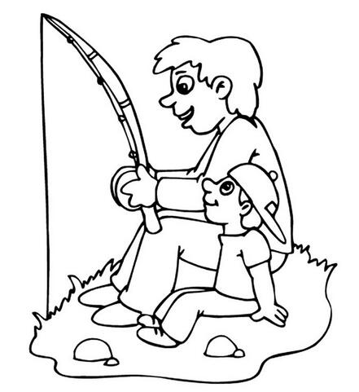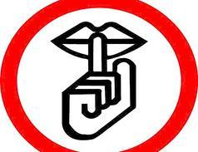
76. father, twice 77. never 78. necessary, library
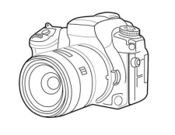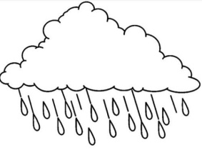
79. use, photo 80. sad, when
VII. 短文填词（共10小题；每小题1分，满分10 分）
阅读下面短文，根据语境、音标或单词等提示，在每个空格内填入一个适当的单词，使短文意思完整、行文连贯。
Have you ever picked strawberries yourself? The sweet fruit looks nice, but light pressure can make them out of shape, so you have to be very ______81______ when picking them. Nowadays, there are many young people who are just like strawberries. They ______82______ (easy) break down when they face difficulties. There is a name for them--- strawberry kids.
______83______ are many children so easy to break down? Because many students are the only child in their daily life. Their ______84______ [ˈpeərənts] do almost everything for them in their life. They ______85______ ever get criticized(批评) at home and always feel good about themselves. If these students are criticized strictly by teachers, they will feel upset and begin to doubt their own ______86______ (ability). Many schools care more about students' grade instead of ______87______ (develop) their personality. As a result, students get satisfying grades while they are not mentally strong enough.
Young people should learn how to make ______88______ [ðəmˈselvz] mentally strong. An expert said, whenever you are in trouble, don't ask for help too quickly. You should try to deal with problem ______89______ (one) by yourself.
Growing up is not just a happy process. ______90______ [peɪnz] also go along. The most important thing is to face them bravely and learn from mistakes.

VIII. 书面表达 （15分）
共享单车(shared bikes)在厦门投入使用以来，给人们带来了诸多便利，受到人们的追捧，改变了人们的出行方式，但同时也遇到了一些挑战，它是国民素质的“照妖镜”，请你根据表格中信息的提示，给《21世纪英文报》写一篇关于共享单车看法的稿件。
社会现状 | 自从出现，饱受赞誉。
诸多优势 | 1.随处可见，出行方便  2.有益健康，减少污染  3.费用不高，负担得起
存在问题 | 1.未及时归还  2.占道挡路
你的观点 | 我认为……(考生自拟，至少2点)

注意事项：1.短文须包括表格中所有提示内容，要求语句通顺，意思连贯。
2.表格中“你的观点”一栏用2―3句话展开合理想象。作适当发挥。
3.词数在90个左右，文章的开头部分已给出，不计入总词数。

Public bicycles are becoming more and more popular in our daily life. _____________________________________
________________________________________________________________________________________________
________________________________________________________________________________________________
________________________________________________________________________________________________
________________________________________________________________________________________________
________________________________________________________________________________________________
________________________________________________________________________________________________
________________________________________________________________________________________________
________________________________________________________________________________________________
________________________________________________________________________________________________
________________________________________________________________________________________________
________________________________________________________________________________________________
________________________________________________________________________________________________
________________________________________________________________________________________________
________________________________________________________________________________________________
________________________________________________________________________________________________

试题结束，请认真检查!

