2020中考英语填词专练
（福建中考）阅读下面短文，根据语境、音标或所给单词的提示，在每个空格内填入一个恰当的词，要求所填的词意义准确、形式正确，使用短文意思完整、行文连贯。
专练一（2017福建省中考）
The Chongyang Festival is a Chinese traditional festival. It is celebrated on the ninth day of the ninth lunar month. It's also 81 (call) the Double Ninth Festival.
The festival started as 82 \ as the Warring States Period (475—221 BC). It has a history of more than 1,700 years. Among the numbers from zero to nine, nine is the 83 (high) odd number (奇数). People believe that two "nines" meeting together stand for a long life. So it is a special holiday 84 Chinese people to show love and respect for their elders. They hold many 85 (kind) of activities in honor of old people, wishing them good 86  and a long life.
The festival comes during the golden time of 87 . On the day, people traditionally drink Chrysanthemum (菊花) wine, eat Double-Ninth Cakes 88 climb mountains. They also carry a kind of plant named dogwood. People in ancient times believed that 89 plant could drive away evil (邪恶的) spirits and prevent them from 90 (catch) an illness in winter.
专练二（2018福建省中考）
Lonnie Johnson always loved taking things apart (分开). He 81 /5sQmtaImz/ put them back together. Other times he made new things from different 82 (part). He learned how to use tools from his dad.
At 13, Lonnie put an old engine (发动机) on a homemade go-cart. He loved driving it around. He dreamed of being 83 inventor. By high school, Lonnie built a remote-control robot from some waste things. This won him first prize at the Alabama State Science Fair. His friends called 84 "The Little Scientist." In college, Lonnie was an excellent student. After that, he 85 (become) an Air Force officer, rocket scientist and business leader. 86 he never stopped inventing. You may have played with his most famous invention—the Super Soaker, a kind of water gun. Lonnie got the idea for this 87 /tRI/ while working on another invention. When he tested a homemade part in his bathroom, it shot water 88 /E5krRs/the room.
Today, Dr. Lonnie Johnson has more than 100 89 (use) inventions. However, he still keeps 90 (try) new things.
专练三（2018福州市毕业质量检测）
After three years of drought, Cape Town (开普敦), the second 8l (large) city in South Africa, is experiencing its worst water shortage in more than a hundred years. The use of water in the city has dropped to 82 /bI5lEJ/ 550 million liters per day. Two years 83 , it was more than a billion liters.
Car washing and filling up swimming pools are certainly not allowed, and 84 (family) have been asked to turn off their toilet cisterns (水箱). What's more, local people have been forced to 85 /tFeIndV/ their habits of using water. Some people 86 use the shower any more; others use recycled water to clean their toilets.
A local beer company, which has a natural spring nearby, has 87 (open)five taps to the public. People are allowed to get the clean and running water from 5: 00 a.m. to 11: 00 p.m. every day. However, as there are too many people 88 (wait) to get water, some of them choose to collect water from 89 /5maJntEn/ streams outside the city.
People are afraid that Cape Town will run out of water in the near future. They call the day when the city's taps run dry “Day Zero” 90 in the city is trying to save every drop of water to push back the date.
专练四（2018泉州市学业质量检测）
Do you know Stephen William Hawking? He was one of the most well known scientists on 81 /speIs/ and time in the world. He was born in England in 1942 and he died at the 82 of 76 on March 14th, 2018. Hawking studied how the universe 83 ( begin) and how it would end.
When he studied math and 84 /saIEns/ at Oxford University, he fell 85 (bad ) ill, which made him unable to speak. Till the last moment of his life, he couldn’t move or feed 86 (him). However, he had a wheelchair with a special computer, with which he could communicate with others.
Although he was facing with all these difficulties, he 87 /rI5 fju:zd/ to give up his hope of living. Because 88 his illness, it was difficult for him to draw diagrams or to write. So he started to think in pictures. With this new way of thinking, he was greatly 89 (respect) by people all over the world.
Once he was invited to China to give speeches. His self-confidence and humorous conversations impressed us deeply.
He once said, “When something unfair happens, 90 is no need to worry about it! You just have to do the best in your own situation.”
专练五（2018厦门市总复习教学质量检测）
On March14, one bright science star went dark, Stephen Hawking, one of the 81 (great) scientists, died at 76 in Cambridge, UK.
As a scientist, Hawking was most famous 82 studying the universe (宇宙)．He thought that the universe 83 /bI5gaen/ with the Big Bang (大爆炸) and will end in black holes.
Hawking was famous not only because of his talents but also because of his strong will. Hawking had a 84 /5sIErIEs/ illness when he was 21. He could not walk 85 talk, but this didn't stop him from 86 (live) a meaningful life. He traveled around, wrote books and even played 87 (he) on TV shows, When he was 65, he tried a flight to experience weightlessness (失重). He hoped to fly into 88 /speIs/ one day.
In an interview, Hawking shared three pieces of advice that he gave his three 89 (child).
One, never give up work. Work gives you meaning and purpose.
Two, remember to look up at the stars and 90 down at your feet.
Three, if you are lucky enough to find love, don't throw it away.
Hawking has left us, but his works and words will live on for many years.
专练六（2018三明市毕业班教学质量检测）
Most Chinese students work really hard to get "A"grades in school. But in the United Slates if you 81 /dVQst/ study all the time and don’t socialize (社交), your life won't be complete. So how does one socialize with students in the US?
Lots of high school soccer games are usually held 82 fall. I didn't know anything about soccer, but I joined in some of the soccer games in order to have fun with my friends. I 83 (think) I could learn the rules from others. However, to my 84 , some American students don't even know the rules but still go to the games in order to socialize. They 85 /tFIE/ for the soccer players and have fun together.
The other 86 /kRmEn/ way to socialize is to join after-school clubs. You can choose clubs that you like and make a lot of new friends. For example, one of my 87 (classmate) started a drawing club. I was 88 (interest) in it and joined the club. I met lots of students there who were fond of 89 (draw). We soon became friends with each other.
Socializing is an important thing in the US. But grades are still 90 , too. A complete student should have the ability to balance (平衡) his or her studying and socializing.
专练七（2018宁德市毕业班质量检测）
Paper-cutting is one of the traditional arts in China, Many people 81 or old, are fond of it. It’s a kind of popular folk art with a history of over 1500 years. A 82 /'WaJzEnd/ years ago, paper-cutting was used for decorations. It's recorded that 83 (woman) in the Tang Dynasty used paper-cutting as headdress. In the Song Dynasty, it was the decorations of the gifts.
In ancient times, people respected the sun, and thought red was the 84 of the sun, So most paper-cutting is red. And people believe paper-cutting can always bring 85 (they) happiness and good luck. At a wedding (婚礼), people put up“Xi” 86 /'evrIweE/. During Spring Festivals, people stick “Fu” on doors, walls or windows．
Paper-cutting 87 (cover) nearly all topics, from flowers, birds to types of facial paintings in Peking Opera. Paper-cutting has various styles in 88 /5dIfrEnt/ parts of China. The largest paper cutting was made 89 two great folk artists. It has an area of about 456 square meters, It is as large as a basketball court.
At present, paper-cutting is 90 (regard)as a kind of art. People in the foreign countries think it is amazing and some of them even come to China to learn paper-cutting.
专练八（2018南平市毕业班适应性检查）
Wu Yishu is a student in Shanghai. She became the subject of hot discussion on the Chinese Internet during the Spring Festival holidays. She beat the others in the 81 (two) season of the Chinese Poetry Conference on China Central Television 82 Feb. 7th.
This 16-year-old girl has 83 (win) the Chinese poetry competition because she has much knowledge of the country’s ancient 84 /'kQltFE/ and works. “I get feelings from ancient poetry that modern people cannot give me. I pay little attention 85 the competition result, but I love poetry, and it is enough as long as I enjoy the 86 (happy) brought by the poetry.” Wu said. In the final, Wu performed strongly in many sections, such 87 competitors recalling poems by looking at 88 /sAnd/ paintings and reciting poems as many as they could think of.
Wu’s strong performance in the Chinese ancient rhythm works earned her lots of 89 /fAnz/ and encouraged others to learn ancient works. She is 90 (know) among her classmates and teachers as she loves reading poems and wearing ancient Chinese clothes.
专练九（2018莆田市毕业班质量检查试卷）
In the western world, Chinese takeout with rice and fortune cook (幸运饼干) is a popular kind of food. But this kind of Chinese food isn't very authentic (正宗的), it is very 81 /'dIfrEnt/ from real Chinese food. Now over the years, real Chinese 82 (dish) have become more popular in foreign countries as well.
Chinese people who live 83 /E5 brRd/ introduced many of them. Some have been popular in foreign countries for many years 84 others are new, like tanghulu. It is a traditional Chinese snack that’s made 85 fruit, usually Chinese hawthorns (山楂). The fruit is stuck on a stick of bamboo. Then it is 86 (cover) with sugar syrup (糖浆) which becomes hard after it cools it cools down.
Wang Jialiang, a tanghulu vendor (摊贩) from China, sold 8,000 sticks in Russia 87 one day. Tanghulu made him 88 /5feImEs/ in Russia, with his picture 89 (appear) in the local newspaper. In the Russian city of Vladivostok, the deputy mayor (副市长) is a big fan of the snack, always coming to buy it 90 (he) from Wang Jialiang.
专练十（2018龙岩市九年级升学质量检查）
Once, people dreamed of a language that everybody in the world could understand. Now, for the first time in human history, 81 /pE5hAps/ there is one-English It is the official language in more than 50 82 (country) and 250-300 million speak it as a second language. Some say that English will be 83
(speak) by half the world's population until 2050.
English is not the 84 (easy) to learn among all languages. It has a large vocabulary -at least 200, 000 words are in 85 /kRmEn/ use. Its pronunciation and written form are also very different, even a little hard. 86 some things make it easy. For instance, there is only one form to speak to someone directly- “you”.
English is used 87 many different areas. It is the language of transport. At sea, English is the international language of 88 (communicate). It is also the first language of science, technology and education. People 89 /stR: / 80% of the information on the Internet in English. And 90% of schoolchildren in Europe study it as 90 first foreign language.
专练十一（2018漳州市毕业班质量检测）
We all use it every day. There is one in nearly every home. 81 is it? The toilet (厕所). A person will spend three years in the toilet in his 82 her life, the World Health Organization said. It’s a big part of our everyday life. Many countries have worked hard to improve their toilets.
To make toilets 83 (clean) and better, the Chinese government carried out a “toilet revolution(革命)” across the country starting in 2015. Over the last three years, the government spent 20 billion yuan building or renovating (翻修) 68,000 toilets in tourist 84 (area).
In Germany there 85 (be) often two rolls of toilet paper in public toilets. They 86 /5seldEm/ run out of their toilet paper. Their tanks are often built into their walls, This 87 (save) a lot of space.
In 88 /dVpAn/, public toilets are not only clean, but also have impressive technology. For example, when the weather is 89 , the toilet seats will be heated.
In Australia, the government provides a national public toilet 90 /mAp/. It shows the locations of over 16,000 public toilets across the country. It also tells people things about the toilets, such as when they are open for use.
专练十二（2017福州市毕业质量检测）
They've got Royal Mail
When Ma Siwen and Zou Wei, two senior students in Yunnan province, wrote a letter to Great Britain's Queen Elizabeth II last 81 /sep5tembE(r)/, they didn’t expect a response. Much to their surprise, they 82 (receive) a reply from Buckingham Palace this January.
The two schoolgirls wrote to the Queen to congratulate her on becoming the longest-reigning monarch(在位时间最长的君主) in British history. They introduced 83 /TEm5 selvz/, their school and their hometown, and invited the Queen to come. According to Ma, they revised (修正) the letter several 84 (time) and spent one week completing the final edition. On the envelope (信封), they 85 eight stamps with the Chinese character Fu to show their blessing and Chinese characteristics.
When they got a reply from Britain, the two girls were quite surprised. “Even I myself felt it was 86 (possible) to receive a word back,” Ma said. She once wrote to 87 /5rQFEn/ President Vladimir Putin and U. S. President Barack Obama, but never got a response.
88 lucky those two girls are! Lets take a look at the royal letter:
Dear Siwen,
The Queen wished me to write and 89 you for your letter in which you tell Her Majesty (女王陛下) a little about yourself and there you live. Although unable to reply to you personally, the Queen was 90 (interest) to hear of your hometown and I am to thank you, on again, for your thoughtfulness in writing as you did.
专练十三（2017泉州市学业质量检测）
Since her husband died, Mrs. Jackson has lived alone in their big old house. The house was 81 (buy) by almost fifty years ago. Her son has tried hard to ask her to sell the 82 and buy a new and small one in the town for safety. But Mrs. Jackson doesn’t like the idea. She says that she has to look 83 her husband’s old house. But recently she often hears stories about unknown people stealing things around there.
That was a cold day before Christmas Eve. Around four o'clock in the afternoon, Mrs. Jackson was enjoying the Christmas 84 /'mju:zk/ when someone knocked at the door. She heard the sound but didn't move.
Another knock. Who could it be? Mrs. Jackson was a bit 85 /E5freId/. She decided not to answer the door but keep 86 (wait).
One minute, another minute and yet another minute, Nothing happened and no more knocks. She walked 87 (quiet) to the door, and listened. She heard 88 but the wind outside. She slowly opened the door a little and watched. She then gave a surprised cry and threw the door 89 /waId/ open!
At the door she saw a tall, beautiful Christmas tree! In the tree stood a Christmas card with these 90 (word): Merry Christmas to you!
专练十四（2017厦门市总复习教学质量检测）
Few years ago, a small town in Taiwan started to grow good rice. The 81 (health) rice was not grown by farmers, but students from an elementary school of only about 82 /5fIfti/ people.
The idea of growing good rice came from the school teachers, While making plans, the teachers decided to 83 students how to grow rice on school land. In their opinions, students needed to get 84 /klEJs/ to the land. And doing farm work outside the classroom is a great way to spend their 85 time.
To their surprise, the rice they grew tasted 86 (good) than the normal rice on the market. Soon, their rice became really popular. The school made money 87 selling the rice and giving farming classes to the public. With the money. the school hoped to help students who wished to go to 88 /fRrIn/ counties someday.
Today the dream is coming true. The students are 89 (invite) to Japan to share their special farming experience, and enjoy 90 (they) there, of course!
“We all feel very proud that even students from a small town can be seen in the world,” said one of the teachers.
专练十五（2017三明毕业班教学质量检测）
Bob was in hospital. His legs were badly hurt in a terrible motorcycle accident. After several 81 (week) of treatment, the doctor knew that Bob’s legs needed to be cut off.
The doctor was 82 /[' freId/ to give Bob the bad news 83 , he gave the sorry job to Bob's wife. He hoped she would 84 /5nEJ/ how to gently break the bad news to him.
“Honey,”Bob’s wife Eva said the next morning, “1 have got good news and bad news. 85 one would you like to hear first?”
Bob answered in his 86 /ju:VJEl/ grumpy (发牢骚的) voice, “What do I care? Just give me the bad news!”
“Well, dear,” said Eva. “I hate to tell this, but it 87 (seem) like your legs are going to have to be taken off.”
Bob cannot stop his voice 88 trembling (颤抖). “what's the good news?”
“The good news”, said Eva 89 (happy), “ is that the gardener said he may be interested in 90 (buy) your shoes!”

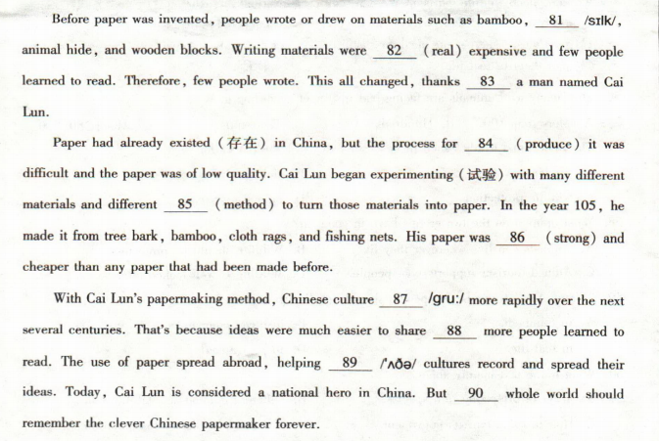
专练十六2019年中考
专练十七2019厦门二检

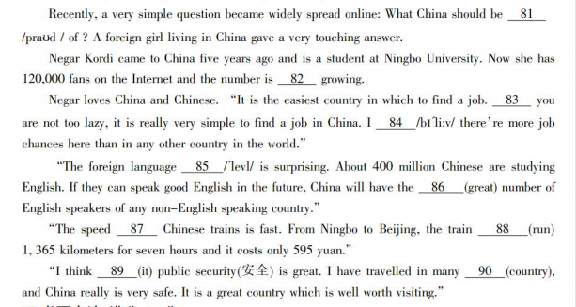
专练十八2019三明二检

专练十九2019南平二检

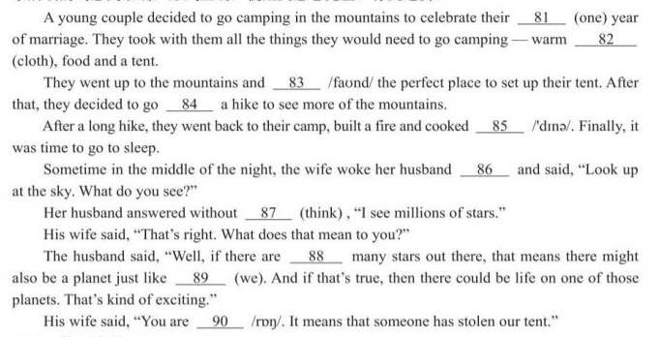
专练二十2019宁德二检
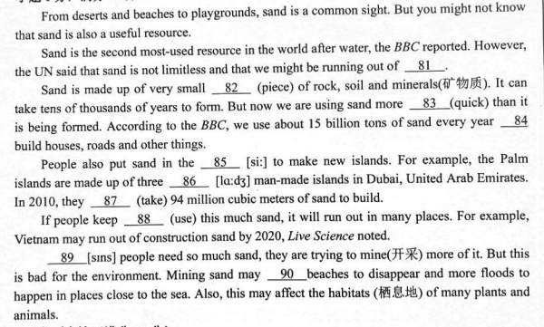
2019莆田二检
